 

Feasibility Study

Of

Employing Spherical Wheels in Car Industry

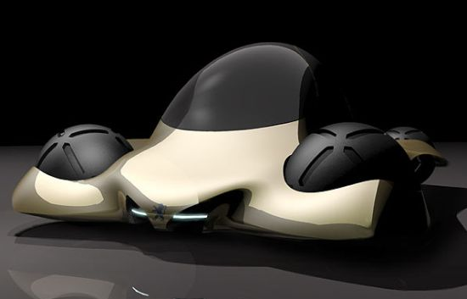

**Prepared for:**

**Mr. Christopher Bauer**

Technical English Instructor

American University of Beirut

Beirut, Lebanon

**Prepared by:**

**Mr. Ibrahim Intabli (***Team**Manager***) Mr. Rawad Malaeb (***Systems***)**

**Mr. Hassan Alame (***Designer***) Mr. Michel Asmar (***Brains***)**

*English 206 Students*

May 27, 2011

**TABLE OF CONTENTS**

FIGURES AND TABLES ………………………………………………………………………….. iii

ACKNOWLEDGEMENTS …………………………………………………………………………….iv

EXECUTIVE SUMMARY …………………………………………………………………………… v

1. INTRODUCTION ................................................................................................................1
   1. Severity of the Issue: Why Sphere?...............................................................................1

1.2 Scope and Limitation of research project ....................................................................1

1.3 Goals And Objectives………………………………………………………………...2

1. DESIGN OF THE SPHERICAL WHEEL ............................................................................3

2.1. Physical Constraints to the Project .............................................................................3

* 1. Introducing the designs and solving for the constraints ……………………………5

1. STEERING CONTROL.........................................................................................................8
   1. Overview:.....................................................................................................................8
   2. Connection and Function:.............................................................................................8
2. MATERIALS TO BE USED:...................................................................................................9
   1. Tyre:..............................................................................................................................9
   2. Brakes:.........................................................................................................................9
   3. Magnetic Core:……………………………………………………………………….9
3. APPROXIMATING COSTS:……………………………………………………………..10
4. CONCLUSION:……………………………………………………………………………10

APPENDICES …………………………………………………………………………………….......... 11

Appendix A: Glossary…………………………………………………………..…………….. 11

Appendix B: Available Permanent Magnets and basic characteristics………..…………….… 12

Appendix C: Solenid Formulae and Calculations…………………………….………………….13

REFERENCES ………………………………………………………………………...………………… 15

**TABLES AND FIGURES**

Figure 1 Free Rolling Wheel: A Sketch …………………………………….…………4

Figure 2 Driven Wheel: A Sketch………………………………………. …………… 4

Figure 3 Fantastic Four Ring……………………………… …………………………..5

Figure 4 Patterns and carvings of wheels for water draining ………………………….6

Figure 5 Fantastic Four Treadmill………………… …………………………..……… 6

Figure 6 Hexagonal Approach to the Sphere…………………………………………... 7

Figure 7 Assembeled System……………………… …………………………..……… 7

Figure 8 Spherical wheel inflated and deflated……… …………………………..……… 7

Table 1 Table of Contents ……………………………………………….……………... ii

Table 2 Basic Characteristics of Common Permanent Magnets ………………………... 8

**ACKNOWLEDGEMENTS:**

The “Fantastic Four” team likes to say a special thank you to all who helped this study become true.

Thank you, Professor Daniel Asmar, for the time you have dedicated to us and for the fruitful pieces of information you have provided us with in our interview held on April 27th, 2011. Our study would have never stood up with secondary sources alone.

Thank you, Professor Marwan Darwish, for recommending the right person for our interview.

Thank you, Mr. Christopher R. Bauer, for all the things you taught us about formatting and English-related issues, as they will definitely come in handy in our future as mechanical engineers, not only in this study. Also, thanks for your comments on our draft; hadn’t it been for them, the organization of the study would have been so lousy.

Last but not least, a warm thank you goes to our colleagues in the English 206 class: Mohammad Alameh, Amira Hachem, Hassan Chamseddine, and Jad Saliba. The team they organized, “Energy Engineers” provided us with meaningful comments, whether grammar-wise or science-wise, to improve our draft feasibility report.

Ibrahim Intabli

Fantastic Four, *Team Manager*

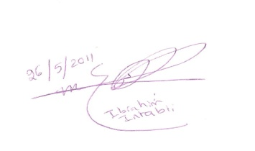

**Executive Summary**

Our feasibility study of employing spherical wheels in cars was inspired by the Audi RSQ car from the movie “I, Robot” released in 2004.

The spherical wheel presents many advantages over the regular, cylindrical wheel, as automobiles with spherical wheels possess the ability to go in all directions, thus easing up parallel parking and car steering and handling.

Employment of the idea of spherical wheels in cars can be achieved by either one or both of the following methods. The first one includes usage of magnetic levitation (MagLev) where a couple of permanent magnets can be centered in the core of the wheel; when alternating and reversing the polarity of the inductors, which are placed at the outer level, we will be able to rotate the sphere. The second method is entirely mechanical. In this latter, two or three smaller, cylindrical wheels are driven by the motor, and the direction and speed of each of those smaller wheels will determine that of the sphere.

In our research, we decided to depend more on primary sources, as only few information has been published and put in the hands of the public, as this topic represents a confidential “weapon” in the hands of large car companies. Our primary key was the interview we conducted with Mechanical Engineering Professor in AUB, Daniel Asmar, on April 27, 2011.

The materials to be used in the components, systems of functioning, and expenses and costs of the idea have been discussed in the paper, alongside with our own designs and AutoCAD drawings.

However, and no matter how far we can go with our ambitions, one must always bear in mind that no motion whatsoever can be generated unless a main principle is satisfied: the principle of making use of friction to change rotational motion from the wheel into translational motion in the car.

**1. INTRODUCTION**

* 1. **Severity of the Issue: Why Sphere?**

Although cylindrical wheels present advantages in the domains in which they are employed, it is inefficient in various domains of automobile performance. This inefficiency appears in tasks such as car parking or responsiveness to high-speed steering to avoid accidents, due to the fact that motion by cylindrical wheels is uni-directional, or as mechanical engineers call it “one-degree-of-freedom” motion. (Lawrence, 2004)

So, why is it that we chose the sphere? The sphere is perfectly symmetrical from all 3 dimensional points of view, and thereby prefers movement in no direction more than the other, thus providing greater maneuverability. It makes it easier to go over obstacles by absorbing shocks more effectively than does a regular wheel. Also, a sphere is more stable.

Given the advantage stated, we had the intuition of looking towards unorthodox ways of designing wheels for the car of the future. Among those ideas is that of the spherical wheel, which is multi-directional, and thus enhances boosting up the performance of cars and their ability to move easier.

**1.2 Scope and Limitation of research project:**

*Scope:*

In this feasibility study, we will focus our research on the following points:

-Researching methods that can be used to allow motion and control of the spherical wheel, in addition to materials that can be used to minimize costs and energy losses.

-Designing and drawing AutoCAD models for the different parts and mechanisms of operation of the system.

*Limitations:*   
Due to time constraints, we are limiting our research to the design phase of the product. In fact, our study doesn’t take into consideration the power consumption rates of utilizing the spherical wheel, as we believe that the concept won’t be implemented until another ten years; that is, spherical wheels is rather for future cars, whose power-related issues are not to be taken out in our study. Also, we were not able to set up the program by which the control system will precisely move the smaller wheels, as you will see in the report later on, due to field limitations, as all members are mechanical engineering students.

**1.3 Goals And Objectives**

Our main aim in this report is to introduce advancement to the wheel by manipulating its design and that of the wheel-containing system, so as to satisfy technological demands, and be able to perform additional tasks many people find it hard to do, such as parallel parking or car handling.

In this study, our team will investigate the feasibility and effectiveness of such a project and try to answer the following questions:

How will the spherical wheel be implemented in car industry?

How can it be controlled?

What are the sufficient materials to be chosen for each component?

Is it cost-efficient?

How practical is this new technology?

Is this new technology recommended?

1. **DESIGN OF THE SPHERICAL WHEEL:**

If one thinks about it, it’s not that that simple to come up with a strategy to design a spherical wheel. And within the process of the design, boundaries come into the big picture to narrow down our expectations. Therefore, our approach to the design was by considering the main physical constraints and obstacles, and by trying to analyze alternative methods so as to bring the design inasmuch feasibility into reality.

**2.1. Physical Constraints to the Project:**

The design of the spherical wheels presents a lot of physical limits and constraints**:**

* + 1. The wheel should be physically in touch with the car to be able to exchange momentum, and work with the car itself.
    2. Wheels should touch the ground, and have a relatively high friction constant.
    3. Free-rolling wheels (the ones not connected to the engine) should be able to absorb frictional work into rotational motion, rendering the translational part of the motion; this is rather better than if frictionless to avoid slipping, and thereby energy losses. (*see fig. 1*)

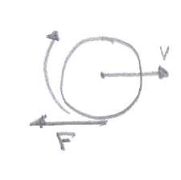

Fig. 1: A free-rolling wheel. Notice that friction opposes direction of motion

* + 1. Motor attached wheels (also known as driven wheels) should be able to transform torque into translational horizontal frictional forces rendering movement possible. (*see fig. 2*)

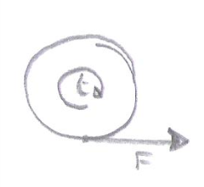

Fig. 2: A driven wheel. Notice that friction takes direction of motion; otherwise, no force would move the sphere.

* + 1. The wheels should have brakes for controlling and parking purposes.

The more advanced limitations however include:

* + 1. The wheel should have designs that suit many climates and weather conditions, including and most of all rain, and wet rode.
    2. The wheel should a control system, that makes driving faster, smoother and of course safer. Like braking, steering, traction control etc.

We then finally reach limitations that concern the spherical wheel and its use:

* + 1. The most obvious advantage the spherical wheel provides over its cylindrical adversary is its high degrees of freedom. And to make sure this is to take place the wheel should not be axe connected to the car/robot, or else one directional motion is inevitable… So we need a control system involving to axial connections what so ever.
    2. Even though the sphere is a pretty much a simple of geometry, its production is not, we need to provide a wheel that is produced with rather ease.
  1. **Introducing the designs and solving for the constraints:**

Solving problems 1, 3 & 8, we introduce the ring with 4 wheels, each 90 degrees apart. This ring is to be the link between the body of the car and the wheel. In fact, it reduces interference, and thereby allows for the 2 degrees of freedom already promised by the spherical wheel (*see fig.3*).



Fig. 3: Fantastic Four ring, with the 4 smaller cylindrical wheels, 90˚ apart.

Solving for both 2 and 6, carrying on the same fashion does the job, so we take the same pattern followed by the designers of actual wheels, choosing rubber as our material for the wheel, and having the latter carved as to help for drainage during driving thereby solving the wet road problem. (*See fig. 4*)

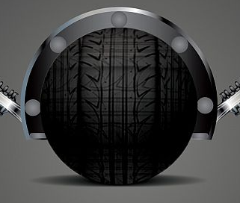

Fig. 4: spherical wheel with patterns and carvings to drain water.

Solving for 4, 5 and 7, in one of the two designs, the small cylindrical wheels of the “Fantastic Four Ring” (*see fig. 3*) will be accompanied by brakes, and motors. The motion of each of these wheels is independent of the others, and it is the combined motion of the three that will determine the overall motion of the sphere. To ensure the adequacy of the motion, the motion of these wheels will be fully controlled by a well - programmed software.

However, solving for 4, 5 and 7, in the second design, we introduce the concept of “the Fantastic Four treadmill belt” (*see fig.5*); this belt is to allow 3 degrees of motion: up and down, clockwise and anticlockwise turning, and turning-about itself. This concept also solves for 8. In fact the treadmill has motor (electrical) powered cylinders, and imposes frictional forces on the sphere, which in turn interacts with the ground and enables the car to move. And the 3 degrees of motion are to allow the wheel to change direction following an organized process; the belt is lifted, oriented in the wanted direction, and then lowered back to power the wheel in the desired direction.

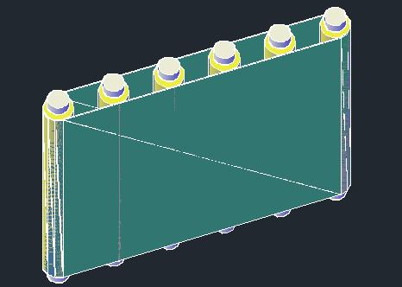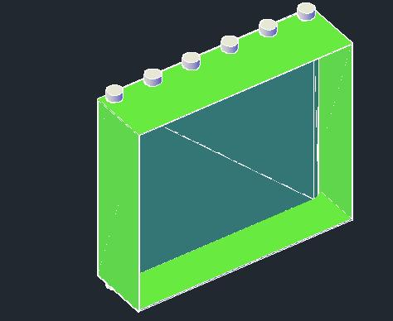

Fig.5: Fantastic Four Treadmill (*a.*) and holder (*b.)*

a.

b.

Finally concerning the ninth restriction, our team was inspired by the soccer ball; in fact a soccer ball is a rubber sphere, filled with pressurized air. And its production is most feasible because of the hexagonal approach to spheres, where hexagon pieces of the wanted material are sewed together to for the sphere (*see fig. 6*).

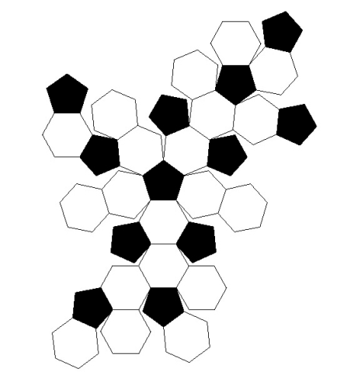

Fig. 6: Hexagonal approach to sphere. Soccer Ball (a.); unthreaded pattern (b.)

a.

b.

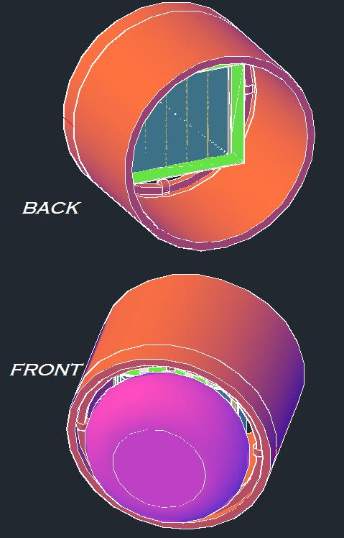

The final assembled system would be similar to fig.7 model.

As we can see in fig.7.b, the sphere is partially deflated to increse area of contact with the ground, thus increasing the taction. Fig.8 clarifies this particular point.

a.

b.

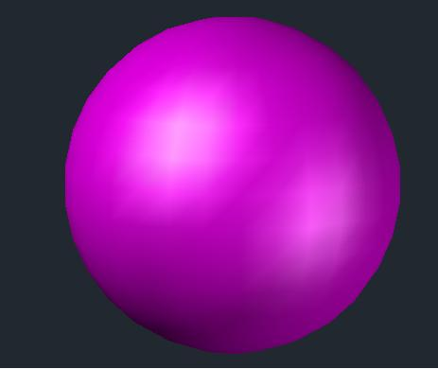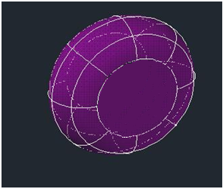

Fig. 8: The spherical wheel: (a.) inflated ideally; (b.) partially deflated

b.

a.

Fig. 7: Final assembled system

1. **STEERING CONTROL:** 
   1. **Overview:**

The car with spherical wheels can no more be driven by a classical steering wheel since it will be faster but rather more precise, moving in all directions. So, instead, a joystick can be used which has a greater precision and driver can control more. This new concept was tested by Toyota that is why we can use in our project. This concept can be achieved by using two joysticks, one used for forward and backward motion and the other for rotating, right and left motion.

* 1. **Connection and Function:**

The joysticks will be connected by wires to the wheels thus sending codes to the magnets and coils found above the wheel (see the design part). It will be very similar to driving an aircraft or helicopter. When moving the joystick to the right or left it will send codes to inductors and thus change the direction of the wheels. Moreover, there must exist a button which disables the rotating and enables the parallel motion; in other words, the whole car moves right or left, which is the most important part of our study, facilitating parking. To do this it requires programs which will take responsibility of changing the speed of the wheels when moving in parallel, rotating around itself; meaning that, to turn in the opposite direction, it will be easier since this type of wheels can fully rotate. In addition, when going into curvilinear translational motion the rear far wheel must have higher speed than the near wheel, same for front wheels but even different speeds from the rear ones. To clarify more, when the car steers into a left angled street, the right wheels have higher speed then the left ones, and the front right has different speed than the rear wheel, in order to avoid slippage of the car. Therefore from the inside instead of classical steering wheel, a joystick will be integrated in the design.

1. **MATERIALS TO BE USED:**
   1. **Tyre:**

Spherical wheels are coated with polyurethane $96°$, which is elastic enough. For this reason, it is very abrasion-resistant. Moreover, it is noiseless and with no vibrations. On the other hand, it can be made out of Nylon which can hold from 500kg up to 1.5 ton. But among our available opinions, rubber is still the best since it can have larger values of friction by its design. Therefore, a spherical wheel covered by rubber not fully inflated so that the point of contact will be not just a point.

* 1. **Brakes:**

The brakes applied to the wheels, are of two types. One part of the braking system will be electrical applied by inductors by reversing the current and thus reversing the motion which is breaking in some way. But it is not efficient since it takes time therefore long distance before stopping, which is why we introduced a new idea, three metal rods connected to the brake pedal; they are arrayed $180°$, covered with material like asphalt or any other type that won’t destroy the rubber layer due to friction.

* 1. **Magnetic Core:**

Now to get deeper into the sphere, it is made of a metal other than iron or steel (aluminum can do the job) or even carbon fiber, alongside with a couple of permanent magnets inside which provides a magnetic field for the inductors to have an electromagnetic field leading in rotating and motion of the spheres. The table in appendix B of this study summarizes the permanent magnets used in our days with their basic characteristics. Among the material available, we decided that Neodymium magnets are the best in this domain, due to their enormous strength.

1. **APPROXIMATING COSTS:**

We conducted research and found out the following results: For each wheel, we need $11,240 as costs of the Neodymium magnetic core (1$/gram), $ 370 for polyurethane with a rate of $ 12.25 per kg, and finally, about $ 5000 for the braking system; thus, the cost of the four wheels becomes $66,440

1. **CONCLUSION:**

As we saw in this feasibility study, employing the idea of the spherical wheel in manufacturing the car of the future is not Mission Impossible; it is quite possible, and major car companies nowadays have turned their insights towards this advanced technology, such as Audi and Peugeot. Nevertheless, we do not recommend the technology for the time being, as our investigation showed how expensive the materials needed are. Also, our study doesn’t take into consideration power consumption rates of the solenoids and large inductors needed to levitate the car and transfer part of the power. We hope the future reveals new materials with high physical abilities and lower prices, as well as renewable sources to empower such car engines. Only then would the technology be recommended.

**APPENDICES:**

**Appendix A: Glossary**

* Friction (*noun*): the force which makes it difficult for one object to slide along the surface of another or to move through a liquid or gas. “When you rub your hands together the friction produces heat.”
* Joystick (*noun*): a vertical handle which can be moved forwards, backwards and sideways to control the direction or height of an aircraft or to control a machine or computer game
* Maneuverable (*adj.*): easy to move and direct. “The new missile is faster and more maneuverable than previous models.”
* Momentum (*noun*): the force that keeps an object moving or keeps an event developing after it has started. “Once you push it, it keeps going **under** its own momentum.” “The spacecraft will fly round the Earth to **gain/gather** momentum for its trip to Jupiter.”
* Shaft (*noun*): a rod which forms part of a machine such as an engine, and which turns in order to pass power on to the machine. “The drive shaft of a car”. “The propeller shaft of an aircraft”
* Torque (*noun*): a force which causes something to rotate (= turn in a circle)
* Traction (*noun*): the ability of a wheel or tyre to hold the ground without sliding. “In deep snow, people should use snow tyres on their vehicles to give them better traction.”
* Treadmill (*noun*): **EXERCISE** a machine with a moving part which you walk or run on for exercise

**Appendix B: Available Permanent Magnets and Basic Characteristics**



Table 2: Available Permanent Magnets and Basic Characteristics

**Appendix C: Solenoid Formulae and Calculations:**

We will consider the magnetic field around one wheel due to the magnet contained in it constant, since its variations are minimal at this range (>1m). Average value of the magnetic field:

B(Neodymium) = 1.0 T

Force needed to make the car levitate over the wheel:

F = m.g

$F=\frac{1500}{4}9.81$ Since the 1500kg car is carried by 4 wheels equidistant from its center of mass

F = 3678.95 N

Intensity of the current needed to run in the coils to provide this force:

 In that case ds is always perpendicular to B

$F=I.2π.\left(0.5+0.1\right).N.B$ Since the car is levitating 0.1m over the 0.5m radius wheel

$I=\frac{3678.75}{2π.\left(0.5+0.1\right).20.1}$ Since there are 20 turns in the solenoid

I = 48.82 A

Resistance of the solenoid:

$R=ρ\frac{l}{A}$

$R=15.87×{10}^{-9}\frac{20×2×π(0.5+0.1)}{π×{0.004}^{2}}$ Since there are 20 turns of the 4mm radius silver wire in

the solenoid and the resistivity of silver is 15.87 nΩ.m

$R = 2.38×{10}^{-2}Ω$

Power needed to procure the necessary current to the coils:

P = 4IV = 4RI2  Since there are 4 wheels that are supporting the car.

P = 4 x 2.38 x 10-2 (48.82)2

P =226.95 W

The power needed is relatively high, but we don’t take the power supply into consideration for this study.

**References (APA Style):**

* Cambridge Dictionaries Online. May 27, 2011. Retrieved from: <http://dictionary.cambridge.org/dictionary/british/>
* The “We’re Not Really Here Thread”, POF Users Forum. May 27, 2011. Retrieved from: <http://www.pofusers.com/pof-users-general-chat-f7/the-not-really-here-thread-t2927-40.html>
* How Magnets Work? By “Tracy V. Wilson”. May 27, 2011. Retrieved from: <http://science.howstuffworks.com/magnet.htm>
* What Are Magnets Made Of? By “J.T. Barett”, eHow Contributor. May 27, 2011. Retrieved from: <http://www.ehow.com/facts_5474922_magnets-made.html>
* Interview with Prof. Daniel Asmar, conducted by the Fantastic Four team on April 27th in AUB
* <http://www.sphericalwheel.com/ing_home.html>